Math as an Area of Knowledge Final lesson

Applied Mathematics: mathematics in the real world.

We think in circles; perhaps, we’d be better served to think in ellipses.

After all, we ‘think’ the earth circles the sun when in fact:

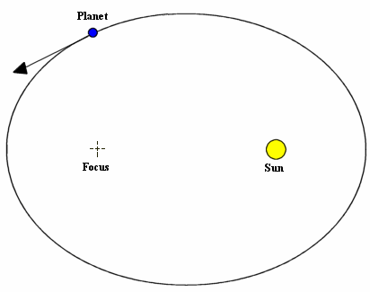

Einstein considered mathematics analytic yet markedly in sync with reality. So, back to our fabulous discussion last week:

Mathematical systems (emphasis mine) ARE invented; however, we discover which systems apply to reality…African fractals.

Any system can be invented; it does not follow it will apply to the world. We can only know which work by way of perception (empiricism).

Riemannian geometry better fits our understanding of physical space than Euclidean.

Buffon’s Needle Problem and pi:

What is pi?

Suppose we have a floor made of parallel strips of wood, each the same width, and we drop a needle onto the floor. What is the probability that the needle will lie across a line between two strips?

Buffon's needle was the earliest problem in geometric probability to be solved; it can be solved using integral geometry. The solution, in the case where the needle length is not greater than the width of the strips, can be used to design a Monte Carlo method for approximating the number π.

Solutions for: 2/π…but how did "π" get there?

Conclusion:

We began in certainty. It is appealing.

However, it is not so certain that certainty is certain…as Godel’s theorem shows.

What we know as certain is the application of axioms that can assist our real life problem solving. And as we discussed, math will continue…to be.

